


Project Navodaya

ABAP Technical Specification

Document Information

Document Number
Title | RAP Application for YRVR077
Document Purpose | Optimization of report YRVR077
Key Words
Document Status | Final
Contact for Enquiries | Mandeep

Document Change Control :
Release | Description | Created by | Date | Reviewed by | Date | Approved by | Date
01 | RAP Application for YRVR077 | Mandeep | 22-05-2025

Header
Area (R/3Module): | SD |  |  |  |  | Date: |  | 22-05-2025
Requested by: | GAIL SD team
Title: | RAP Application for YRVR077
Short description: | Optimization of report YRVR077
Functional Developer: | Pankaj Wadhwa (SAP) |  |  |  |  |  | Phone: | +91
Technical Developer: | Mandeep Singh Bhatia |  |  |  |  |  | Phone: | +91 9871431173
Program name:
Type: | Change Request Development Request(Creation) Rework
Program type: (select the check box) | Conversion Batch Interface Online Interface Report  Form Enhancement Extension Dialog  Modification Unknown Others BAPI  ALE/ IDOC Application Development
Priority: | Very High High Medium Low
Complexity: | Very High High Medium Low
Specify known SAP functionality: |  | <Specify the related SAP transactions>
Cross Reference Documentation:
Only for Interfaces:  Type of interface:  Direction of interface:  Frequency: |  |  |  | Real-Time Batch  Inbound Outbound Both  Daily Weekly Monthly  Biweekly Other:
Only for Reports:  1. The report will be created via:  2. Requested characteristics: |  |  | Standard Report  Report Painter Report Writer ABAP Query  ABAP Program Info System  Drill-down Pushbuttons Sort  Entry files Others: _____________________
Generic question:  1. Impact of not creating the program: |  |  | legal requirements will not be fulfilled  lack of information required for the business  lose functionality compared to the old system  others: could have duplicate data entered into the system_
Development labor estimate:
Are there any alternatives in the standard system: |  |  |  |  | Yes No
Describe the alternative found:
Reason why this alternative was not acceptable: |  |  |  |  | Performance problems Complexity  Others: The transaction to initiate

Technical Specification
3.1. Technical Report Created:

Root CDS: ycds_yrvr077
Entity Set: ycds_yrvr077
Service Defination : YSD_YRVR077
Service Binding : YSB_YRVR077

Development Overview

Sr. No | Program Name | Transaction Code | Transport Request No | Dependency/ TR Sequence
1 | YECC_PDR_REPORT_YRVR077 | YRVR077 | SBRK902843

Development Details

Code
Screen:
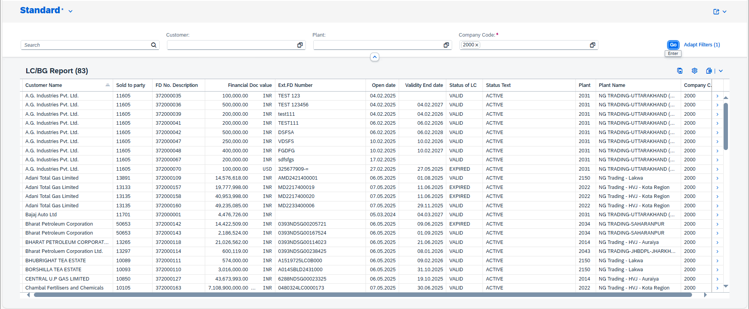

Logic:

1. CDS: I_BusinessPartnerCustomer(a)
This CDS view fetches all customers based on the condition where customer is not empty.
  - tlct_activity (b)
rfha, rfhazu, applicant, cre_amt_curr, credit_amt, lc_number and bg_number are fetched from this DB table on a inner join with condition as a.businesspartner = b.applicant and a where condition as b.rfhazu = (‘00002’ or ‘00030’ or ‘00031’).
  - Vtbfhazu (d)
delfz and yy_status are fetched from this table on a left outer join with condition b.rfha = d.rfha, b.rfhazu = d.rfhazu and d.saktiv = '0'.
  - Vtbfha (e)
dcrdat, sgsart, saktiv are fetched from this DB table on a left outer join with condition b.rfha = e.rfha and b.bukrs = e.bukrs.
  - kna1 (h)
name1 is fetched from the DB table with a left outer join on condition a.Customer = h.kunnr.
  - knvv (i)
vkorg and vwerk are fetched from this DB table with a left outer join on condition a.Customer = i.kunnr and i.vkorg = b.bukrs.
  - t001w (j)
name1 is fetched from this DB table with a left outer join on condition i.vwerk = j.werks.
2. CDS: YSH_BURKS
This CDS view is associated with the root CDS view and fetches company code, name of company and city from database table “T001”.
3. Root CDS: ycds_yrvr077
This root CDS is made up from the above-mentioned logic with select from
I_BusinessPartnerCustomer, one inner join, five left outer joins and one association to
YSH_BURKS.
4. Metadata : YMD_YRVR077
Once the data is fetched from the CDS, a metadata is created to define the UI of the fiori app.
3. Service Definition Exposure: YSD_YRVR077
Once the metadata is defined for the CDS view entity elements, it is exposed through a service definition. This step makes the data accessible for external systems to consume.
4. Service Binding and Maintenance: YSB_YRVR077
The service definition is bound and maintained. This ensures that the service is available to the desired applications and users.
5. Fiori Tile Creation and Role Assignment
A Fiori tile is created to display the data exposed by the service. Additionally, roles are assigned to ensure that only authorized users can access and view this tile.

Table Creation
N/A

Security /Authorization
N/A

User Exit
N/A

Transaction / Batch Job that will access enhancement
N/A

Anticipated performance Issues (if any)
N/A

Registration
N/A

Assumptions/ Notes

Unit Test Case
Screenshot for testing

- Report Screen:

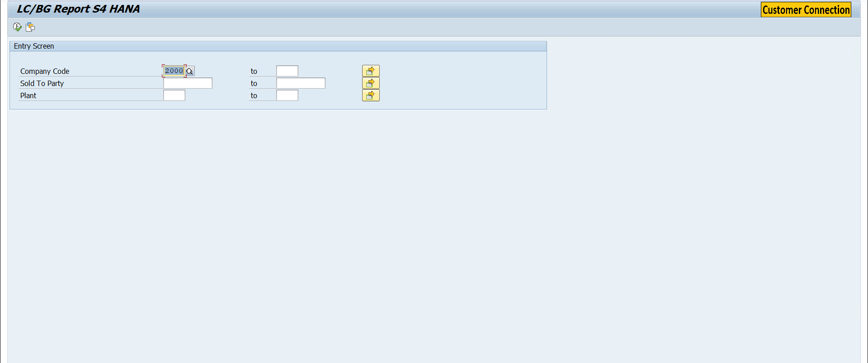
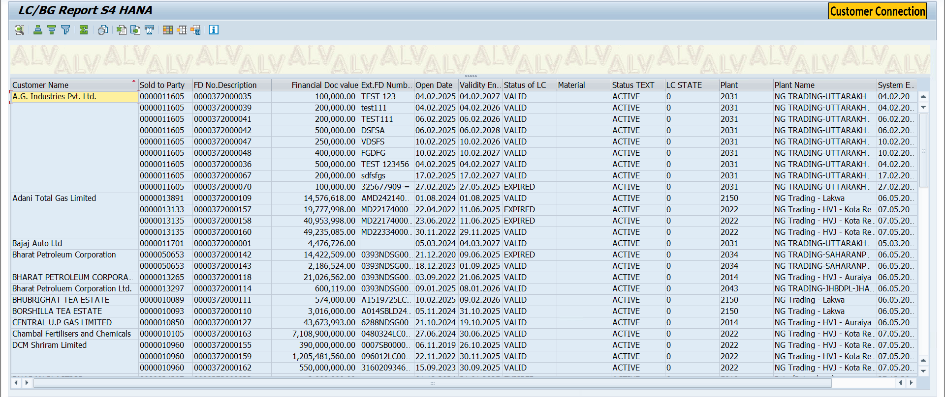

- Fiori Screen:

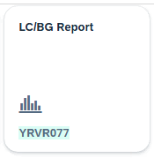



Technical Spec Original Sign Off:

Names and Signatures:

____________MANDEEP SINGH BHATIA____________ Date: ___22/05/2025________

____________________________________________________ Date: _____________

____________________________________________________ Date: _____________

____________________________________________________ Date: _____________

Modifications
< Description of Modification if any>
<Support document of the modification like screen shot of email received>

